Redesign of GJ114 Suite:
with focus on acoustic damping
Objective: Improve room acoustics in the UI ME Senior Design Suite: Gauss-Janssen 113
Expected Timeline: Phase 1(~$25k) Fall 2020, Phase 2(~$250k) Spring 2021
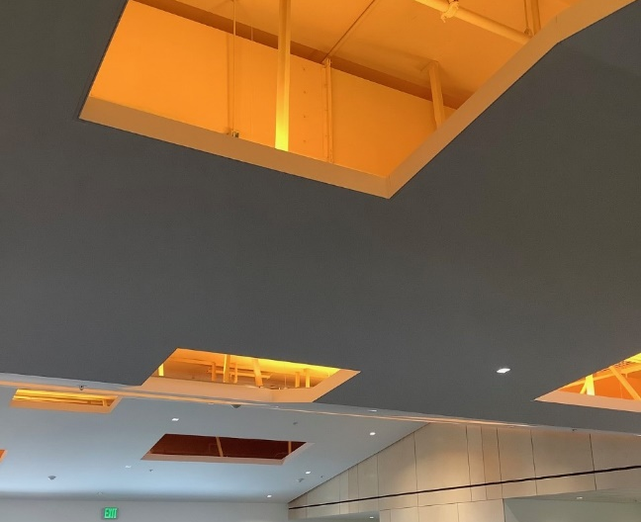
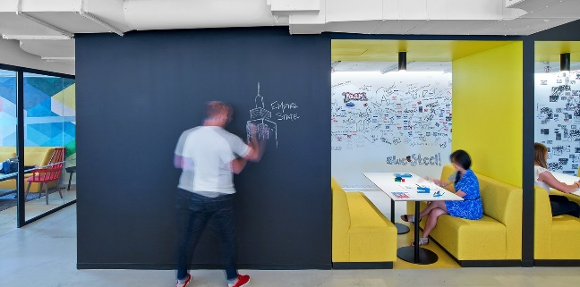
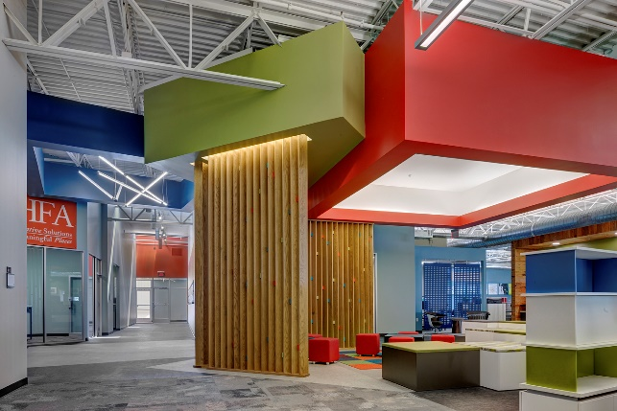
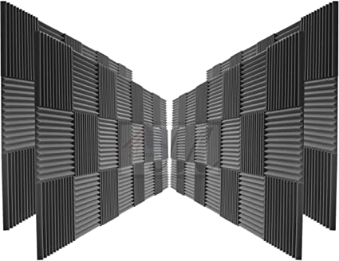
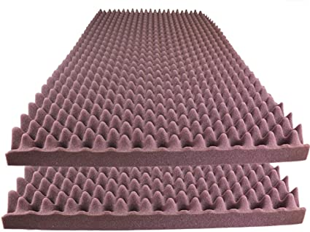
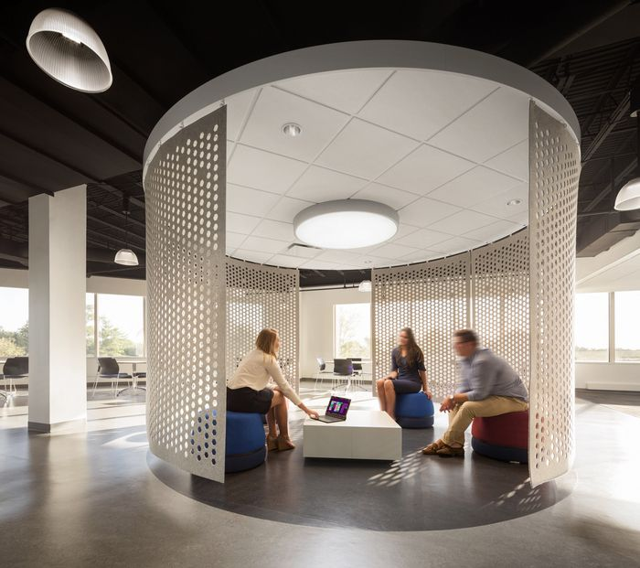
Inspirations:

Clockwise from Top Left:
1: Open space with damping panels at HFA headquarters, 2:Cylindrical meeting area with sound grating, planned for use in center of design suite, 3:Milk carton and Triangular pattern closed cell foam, used for sound cladding on walls and panels, 4: Stepped ceiling with exposed cavities, useful for reducing room reverberation for high-ceiling spaces, 5: Open space cubicle at LinkedIn-NYC, with chalkboard.
Guiding Principles: 1) Add as much surface area as possible
2) Reduce effective ceiling height from 20 to 10 ft
3) Use 2-5 inches of closed cell foam for panels for max sound deadening
4) Add windows to north wall
5) Add movable central display space to room, for showcasing projects and meeting with clients.
Methods: Solid Modeling completed in Catia V5 on my personal computer.
After researching on the subject of architectural acoustics, and interviewing Prof. Micheal Maughan and Ned Warnick (a Vandal alumnus architect at Design West PA), a few design principles were outlined.
1: The human voice falls in the range of 2k-5k Hz. That is the main noise we wish to reduce in that space, so this was the selected acoustic range.
2: For 2k Hz, an insulation thickness of 6 inches is required, and only 2 inches are required at a frequency of 5 Hz. For this reason, a design goal of ~5 inches foam thickness was selected.
3. The most significant way to decrease reverberation is to increase available surface area to reflect sound. For this reason, a suspended false ceiling with a stepdown and abscesses was selected to increase area, in addition to adding anechoic foam on the existing wall surfaces and sliding panels.
Simulating the acoustic feedback of a room is very difficult, so we elected to propose best practices to be implemented during the 1st and 2nd phase of construction in the Gauss-Jansenn building. It would be best to add anechoic foam to the currently free wall surfaces during phase 1 (~$50k budget allotment), and adding the false ceiling and associated hardware during the phase 2 (~$250k budget allotment).

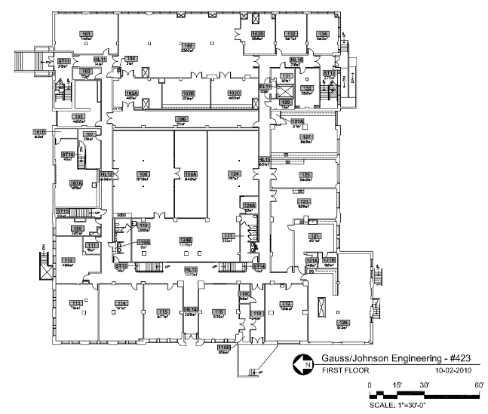
Design Process:

Starting with the floorplan of the design suite (found of the UI website) allowed me to know the dimension of the room for modeling.
The main room is 30’x40’(N-facing wall), and the attached work room is 15’x40’.
The ceiling height was assumed to be 20’.
Wall thickness was assumed to be 4.25”.
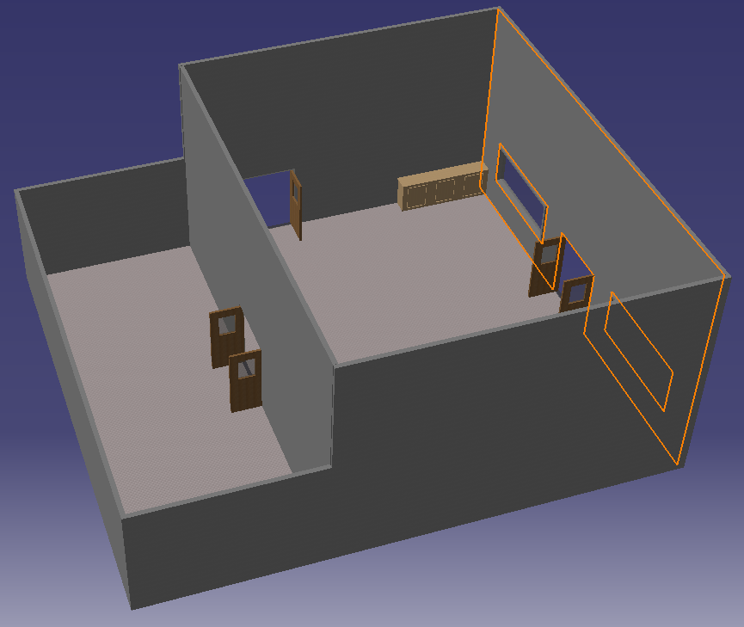

The room was then modeled in Catia, with the North facing wall selected on the image. Windows were added to the North wall, as seen below, to allow vision from the attached hallway into the design suite.
Doors and cabinets were also added to the model to aid in placement to avoid collisions.

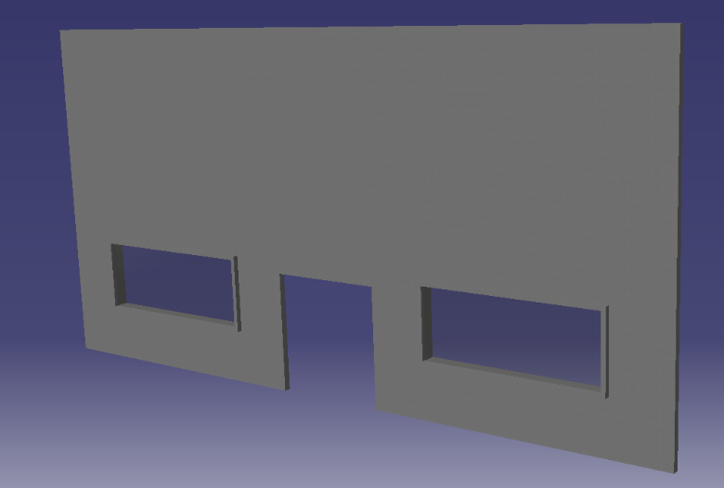

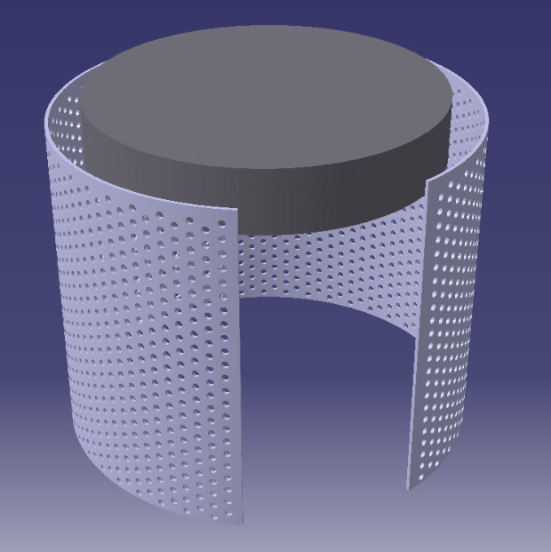
Finished Center assembly. This was done by revolving a profile and the patterning 2 offset lines of holes. This bottom of the overhead piece is 8 feet above the floor.
If actually manufactured, It should include castors to make it movable. A useful addition would allow the room to be completely enclosed, either by a sliding door or a folding hinge in the middle.

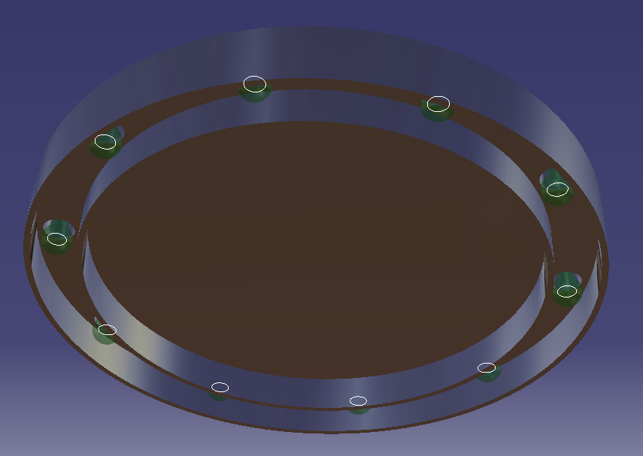
The ceiling light fixtures were designed to fit onto the sound diffusive geometries suspended from the ceiling. They contain a patterned ring of 10 lightbulbs, which can be seen to the right. For simulation purposes, this will be useful to place a light in each one and then let the pattern tool replicate it to all the others.

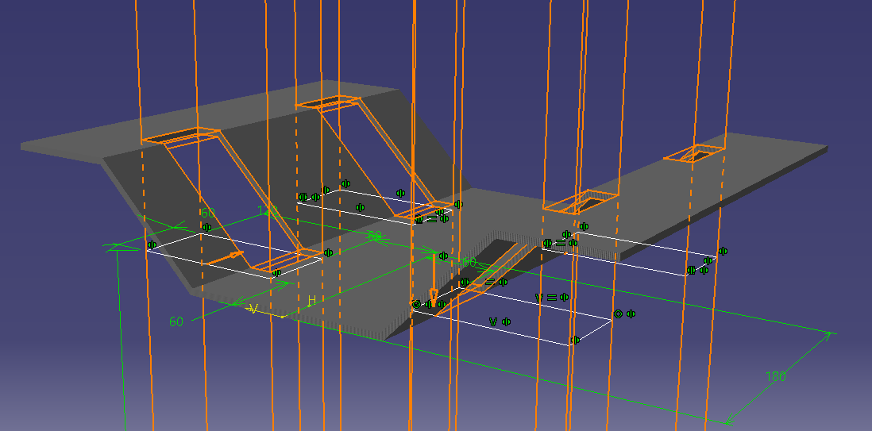

The dropdown ceiling was designed by extruding the cross section to the dimensions of the room, and then adding 4 equal through all cuts. The ceiling thickness was chosen to be 5 inches for highly effective deadening properties.

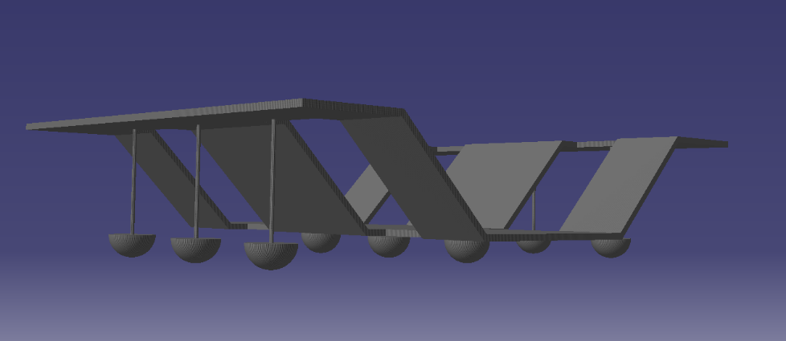
Dropdown ceiling with extruded cables suspending diffusive geometries. The hemisphere shape was chosen for its diffusive characteristics; it will scatter sound in all different directions. One shape was built and then patterned, and a cable was extruded to connect the two surfaces.

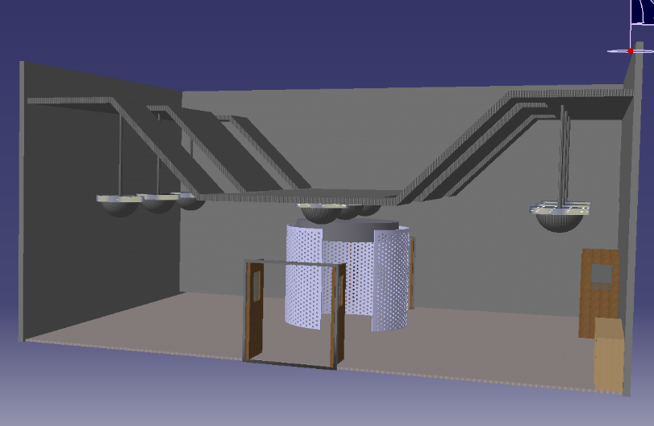

Here the completed ceiling and center assembly can be seen in the room model. The center assembly is placed where it is to help isolate the attached rooms from each other, by acting as a block toward oncoming sounds.

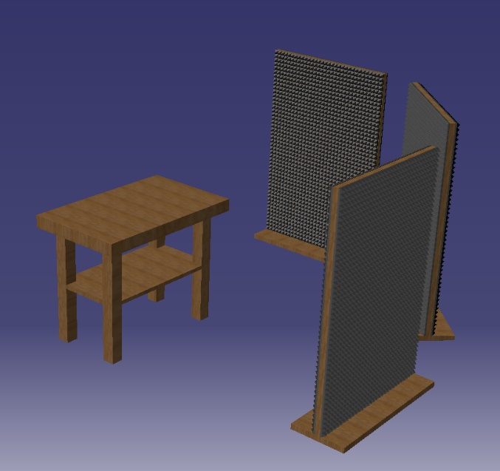

Workstation assembly, with workbench and panels. This layout is highly effective because it protects from sound in two directions for a corner table, with an additional third panel to slide into place if needed. After designing it was realized that these panels could be on sliding rails, which would allow 3 panels to only take up the floor space of one when not in use.

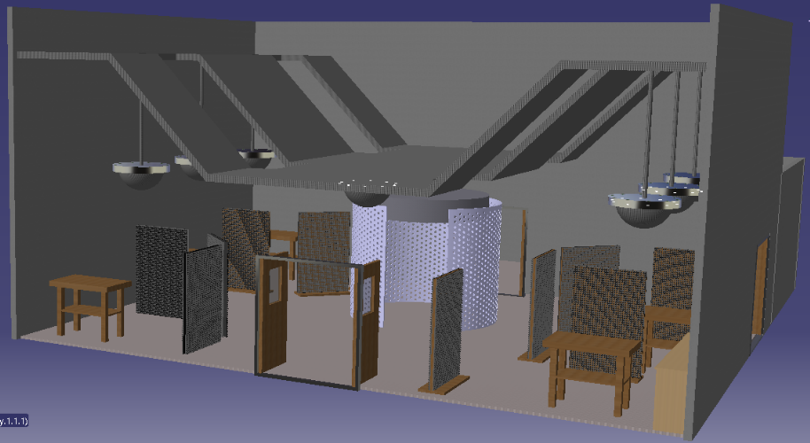
Results: Final result pictured here with North wall hidden.
With all workstations in place (SE robotics corner ignored), the room layout would be as pictured. The Lower height of the false ceiling is 10 feet, but it would be beneficial to come down to 8 if that still meets city building code. The ceiling raises at a 45 degree angle, and it would still be functional if the upper height was reduced or the angle was decreased.

Conclusion and Recommendations:
Add ~3” anechoic foam to walls surrounding workstations at bare minimum. Movable 5” floor panels between workstations would be helpful to reduce noise further but are not necessary. These can both be achieved in phase 1 of the project.
The most significant noise reduction will result from a reduced ceiling height. To maximize efficiency at directing sound upwards, a stepped ceiling and/or sound diffusion surfaces are required, as demonstrated in the model above. This will come during phase 2 of the room remodel. This will have to involve rerouting the overhead sprinklers and adding LED lights for the room and spotlights for each workstation. For this model, the lights were placed on a hanger that rests on the top of the diffusers that are suspended from the false ceiling.

